1. Write a Program to design Lexical Analyzer in C/C++/Java/python language(to recognize any five keywords,identifiers,numbers,operators and punctuation)

kwd=['int','float','char','if','else']

oper=['+','-','\*','/','%']

punct=['.',',','!']

def func():

txt=input("Enter text")

txt=txt.split()

for token in txt:

if token in kwd:

print(token + "is keyword")

elif (token in oper):

print(token + "is operator")

elif(token in punct):

print(token + "is punctuator")

elif(token.isnumeric()):

print(token + "is number")

elif(not token[0].isnumeric()):

print(token + "is identifier")

else:

print(token + "is not valid identifier")

func()

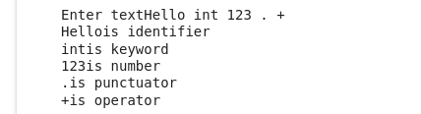

1. Write a Lex Program that copies a file,replacing each nonempty sequence of white spaces by a single blank.

%{

#include<stdio.h>

%}

%%

[\t" "]+ fprintf(yyout," ");

.|\n fprintf(yyout,"%s",yytext);

%%

int yywrap()

{

return 1;

}

int main(void)

{

yyin=fopen("input1.txt","r");

yyout=fopen("output.txt","w");

yylex();

return 0;

}

Input.txt

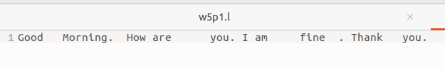

Output.txt

